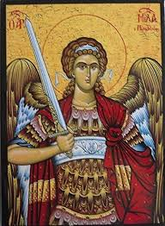
St Michael Class Newsletter Autumn 2026

Dear Parents,
I hope your family have had a lovely summer holiday. The children have settled back well and have shown great enthusiasm about their return to school and starting Year 5. This newsletter is to update you on important information that you need to know for this term so that you can support your child’s learning from home. Miss McClements
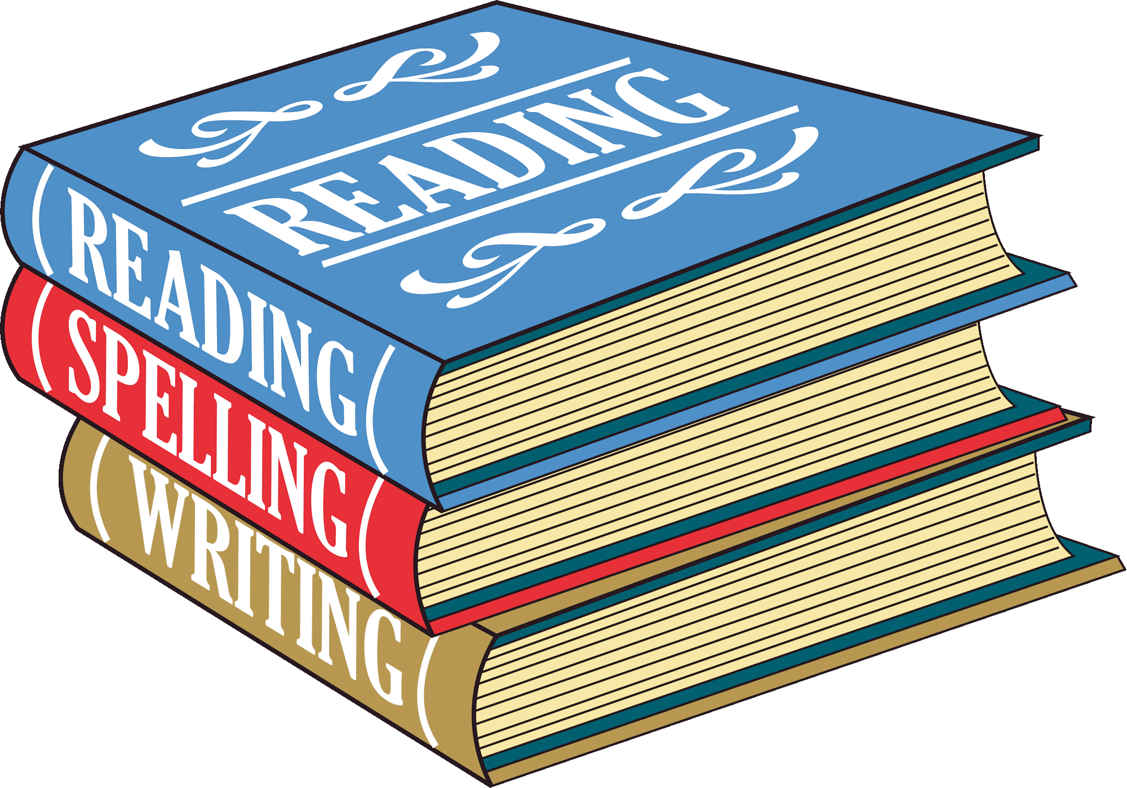  English | We use the Essential Writing scheme to facilitate learning in our English lessons. This scheme provides children with lots of opportunities to write in a range of genres and engage in rich talk stimulated through a high-quality text. We are currently working on a short unit of work on poetry. Very soon, we will begin a narrative unit on writing short stories. Later in the term we will be writing non-chronological reports using a book called ‘Planetarium’ to inspire us. Please visit the school website at https://www.stpatricksprimary.org.uk/st-michael-class/ for more details about English this term. There are many opportunities for reading throughout the week during shared reading sessions. In Year 5, children are expected to write 4 comments about their book in their reading journal every week. Spellings will be set for homework each week on Spelling Shed ready for the test in class the following week.

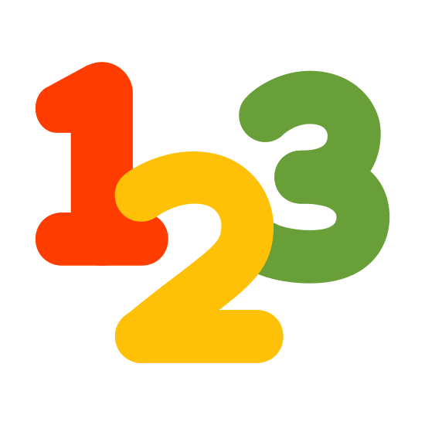  Maths | Please visit the school website at https://www.stpatricksprimary.org.uk/st-michael-class/ to find the long-term plan of the maths concepts that will be taught this term. We have started with place value. Maths homework set each week will be a consolidation of the work covered in class. Children in Year 5 are expected to know all their multiplication tables up to 12 x 12 so if your child is not confident in this yet any additional practice you can do at home would be of great help. The Times Table Rockstars App is highly recommended. The children have log in details for this in their reading journal.

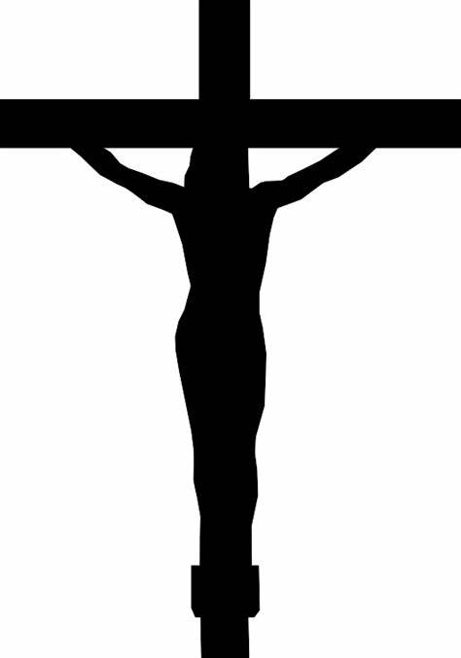  RE | This term, the children will explore how following a code of behaviour helps people find true happiness and grow closer to God. They will study the concept of a covenant alongside key teachings like the Greatest Commandment, Catholic Social Teaching, and the cardinal virtues.
Class Assembly: Friday 2nd October 9am
Class Mass: Wednesday 2nd December 9am
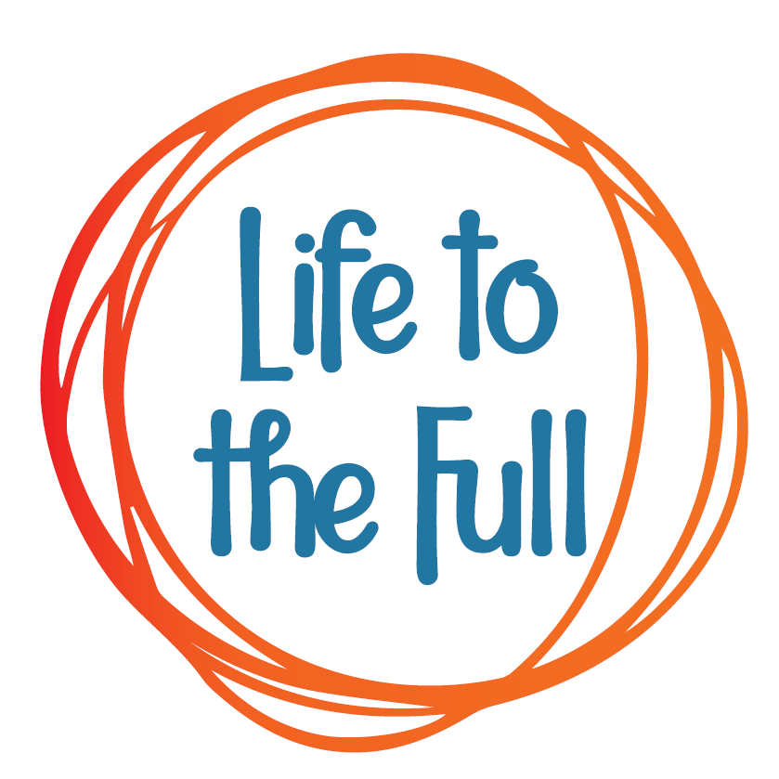 Relationship Health Education | We will use the Life to the Full scheme produced for Catholic primary schools to teach a unit called Created to Live in Community.

  Science | Our Science topic this term is ‘Changes of materials’. We will carry out a range of investigations into the changes in certain materials when they are heated, cooled and mixed. After the half term, the children will be learning about ‘Forces.’
  Computing | The Purple Mash Computing Scheme of Work will be used to cover three units of study this term – coding, online safety and spreadsheets.
  French | French units that will be covered are Family and Friends and Our School.
    Geography  History | The children will study the formation of Volcanoes and explore an active volcano in Iceland.  Later this term, we will study the Benin Kingdom. An important civilisation, widely known for its amazing bronzes.
  Music | Music is taught by a specialist teacher. The children will be taught how to play the ukulele in whole class instrumental lessons.
  PE | The children will need their PE kit on a Thursday when they have outdoor PE. This term the children will focus on Football and then Hockey. Miss Leyla will also teach dance to the children on a Thursday. For the first half term, we will also have swimming each Tuesday.
  Art | The children will be looking at the work of Leonardo Da Vinci, exploring his drawings of invention and iconic paintings.
  Design & Technology | This term’s unit is called Textiles. The children will be combing different fabrics to create an applique.
Homework |   Homework is set on a Friday and needs to be completed by the following Tuesday. The following Apps can be accessed at home to support learning.

