St Theresa Class Newsletter Autumn 2026

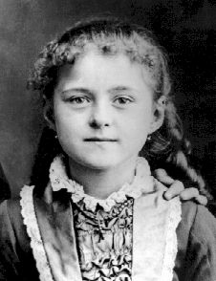
Dear Parents,

What a wonderful start to Year 1 we have had! Children are settling into new routines, becoming familiar with their classroom environment and building relationships with their new teachers. Thank you to everyone who has begun annotating in reading journals. In year 1, we recommend that the children read a little each day and that parents record it when finished. Should you have any questions about this, please do not hesitate to speak with me. This newsletter will update you on important information regarding this term. It’s going to be a great year!

Miss Piscitello

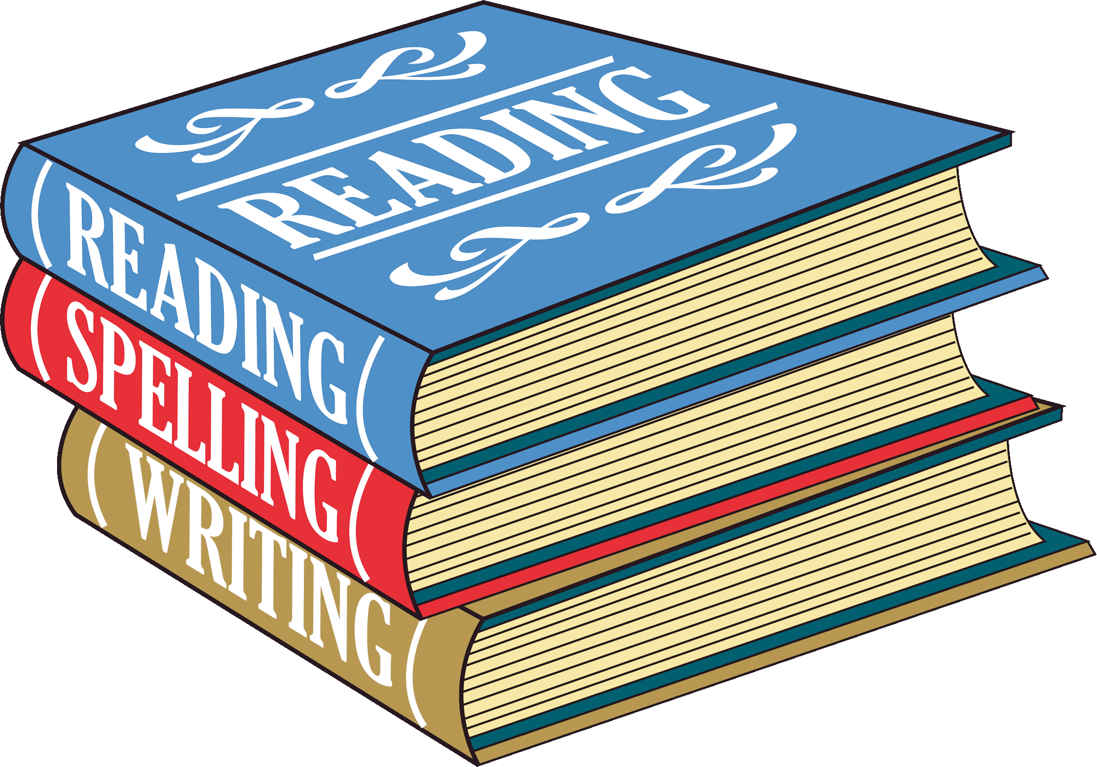  English |  | Writing:  We will be using the Essential Writing scheme to facilitate learning in our English lessons. This scheme provides children with lots of opportunities to write a range of genres and engage in rich talk. This will involve oral rehearsal to write grammatically correct sentences with a specific emphasis on purpose and audience for their writing. The first book the children will read and model their writing after is called “Jasper’s Bean Stalk.”  Reading: Your child will have the opportunity to read individually as well as in a group through shared reading sessions throughout the week in order to develop fluency and reading comprehension strategies. It is great if the children read at home each evening to an adult. (Their book will be changed once a week.)  Spelling: We use the Floppy Phonics Scheme to systematically teach children in a daily phonics session. In addition to this, we will set up a list of words for you to practise at home with your child. As many of you know, in June, there will be a government phonics screening check for all Year 1 children, and your support will reflect your child’s confidence in naturally decoding and understanding text when reading. More details of this will be shared at a parents’ evenings before half-term.
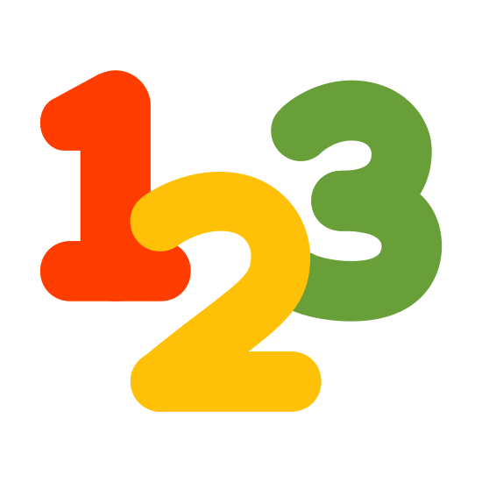  Maths  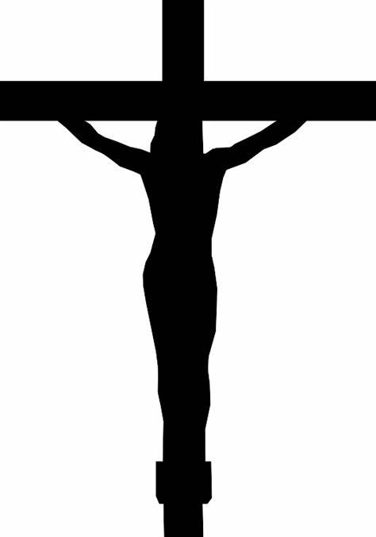  RE  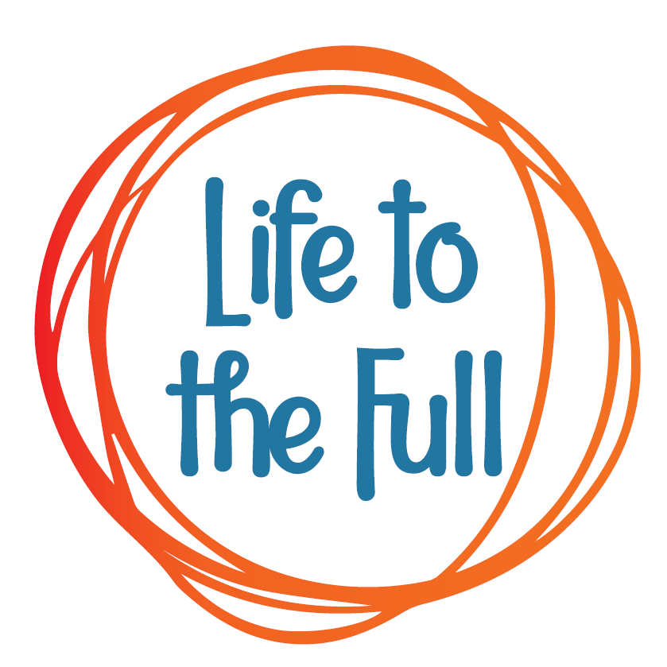 Relationship Health Education |  | This year we will use the Essential Maths scheme, which is designed to develop children’s fluency and confidence with number facts. The scheme builds a deep understanding of how numbers work, moving beyond counting in ones and encouraging children to learn a range of mental strategies. In class, we will provide a variety of resources and visual aids to support their learning and ensure all children can access and apply these skills with confidence.  This term, we will think about ‘God’s Great Plan’ with the creation of our beautiful world and how we can care for it. We will look at the Bible stories of how God made the world, Adam & Eve and Noah & the Flood. Later in the term the children will prepare for Advent by learning about ‘Mary, Our Mother.’  We will use the Life to the Full scheme produced for Catholic primary schools to teach a unit called Created and Loved by God
  Science |  | Our first topic is Different Animals. We will begin this term by looking at our own bodies and senses. We will then move on to looking at the different varieties of common animals. Next half-term, our topic will be Seasonal Changes. Children will learn about the four seasons and the different types of weather.
 |   Computing |  | The Purple Mash Computing Scheme of Work will be used to cover the units of study on Online Safety, and Exploring Purple Mash
 | 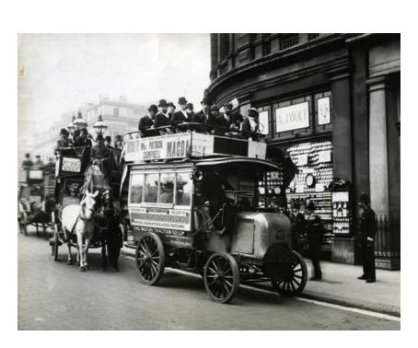  History |  | Homes in the Past Children  The children will learn about how homes have changed throughout history. They will have the opportunity to experience first-hand what a home would have been like back in the Victorian Times. Please visit the school website for our ‘Knowledge Organiser’ of the key facts that children need to know from this topic.
 |   Geography |  | What is the geography of where I live?  After the half term, children will learn about the geography of where they live.
 |   Music |  | Children will begin by exploring pulse, rhythm and pitch. They will be singing and playing instruments.
 |   PE |  | On Tuesdays, children will be taught dance by a specialist dance teacher. On Wednesday, children will have outdoor PE. This term the children will focus on games and gymnastics. Please do ensure children bring their full PE kit to change into on Thursday morning.
 |   Art |  | This term the children will be exploring collages. The theme is My Family. After half term we will have fun making animal art using Papier Mache.
 |   Design & Technology |  | The children will be learning about Mechanisms by making models with sliders and leavers.
 | Homework |  | Homework is set on a Thursday and needs to be completed by the following Monday.  The following Apps can be accessed at home to support learning.  
Important Dates:

We are all looking forward to seeing you at the following events!

- Class Trip – Thursday 8th October 2026
- Class Assembly – Friday 27th November 2026
- Class Mass – Wednesday 30th September 2026

