Year Reception – Autumn Term Newsletter 2026
St. Bernadette Class
St. Francis Class

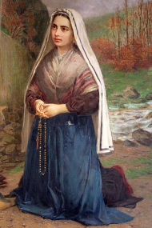
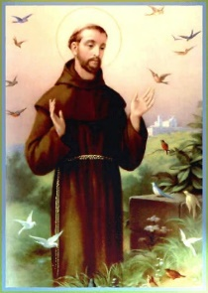

Dear Parents/Carers,
Welcome to Reception! We have had a busy and fun-filled week getting to know the school geography, class routines and, most importantly, our new friends! This class newsletter will outline some the topics and activities we will be covering this term.
Our topic for the first half of the term is ‘All About Me’ where we will learn all about our interests, our bodies, our emotions, our five senses, how we have changed since we were babies, as well as learning about our families and friends.

Our topic for the second half of the term is ‘Special People’ and we will reflect on how we are all special beings made in the image and likeness of God. We will think about who is special to us in our family, in our school and in our community.

English: Over the course of the term, we will be helping the children enjoy rich stories as a stimulus for role play and language development. We will be ensuring the children have a comfortable and efficient ‘tripod’ pencil grip to mark-make using a variety of media.

Maths: This term the children will be focusing on number, shape, size and patterns. We will be learning some number songs and rhymes, counting forwards and backwards, accurately counting sets of objects to find the total and securing 1:1 correspondence. We will read, write and order numbers in fun games contexts. Please help to encourage your child’s interest in number by asking them to count different objects, e.g. counting the steps as you walk up/downstairs, or by reading numbers on car number plates/buses.

Phonics: We will be using Floppy Phonics in class to learn the different letters and their sounds. Each letter or ‘letter group’ has a song and an action to help your child remember the sounds they make. Please talk to your child about the sounds they have learned in school, allow them to share the actions with you and play games such as ‘I spy with my little eye’. Further information on our phonics learning will be provided next week in our Parent’s meeting.

PE: PE will take place once each week – please bring PE kits in on a FRIDAY. This term we will be focusing on travelling, balancing and dance. Your child will be practising moving at different levels, development of spatial awareness, and learning how to use their body to move in a variety of ways and directions. They will also learn to stop on a given signal and use suitable apparatus during their lessons.

It would really benefit your child if you help them practise getting dressed independently at home, so that they will be able to do the same during PE time in school.
The PE kit consists of: a white polo t-shirt and black shorts. In winter, a black tracksuit can also be worn over the top of the children’s t-shirts and shorts.

PLEASE BRING PE KITS IN A LABELLED BAG. CHILDREN ARE STILL REQUIRED TO COME TO SCHOOL IN FULL UNIFORM AND ARE SUPPORTED IN CHANGING FOR PE WITHIN SCHOOL.

Music: In Reception, children are encouraged to sing a range of well-known nursery rhymes and action songs. They explore a variety of singing opportunities that help develop their language, memory, and musical skills such as rhythm, pitch, and tone.

RE: We will be following Lighting the Path programme this year for religion. Our theme for this term will be God’s World and God’s Family. The children will learn about God’s love for them and about all the beautiful things God created in our world. We will be beginning with the story of Creation and then think about how we can look after the world God created for us.

RHE (Relationship & Health Education): This term, we will be exploring ourselves as individuals, knowing that we are created and loved by God. We will be learning and understanding the importance of valuing ourselves, as the basis for personal relationships.
Reading: In the next coming weeks, we will be sending home a story book for you to read to your child and home structured reading scheme books that we use to support your child’s early reading development.
Homework: Homework will be given out every Friday, and is to be returned back to school the following Tuesday.

We look forward to getting to know you and your children over the next year at St. Patrick’s!

Mrs Modi & Miss Cheese
(Class Teachers)


